Electron Configurations
The following chart shows the relative amounts of energy that the electrons in each sublevel have. (Lowest energy is at the bottom, and highest energy is at the top.)
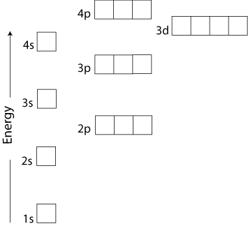
In the ground state, electrons always go to the lowest-energy sublevel that has an available “slot”. This means that the electrons will fill sub-levels in the following order:
1s, 2s, 2p, 3s, 3p, 4s, 3d, 4p, ...
The following “road map” shows the complete order that sub-levels are filled, from lowest to highest energy:
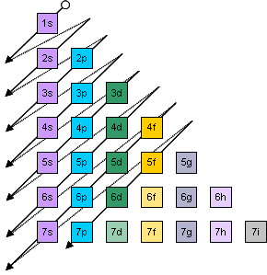
To read this map, start at the top. The arrow leads you through the sub-levels in order, from lowest to highest energy. The arrow goes through 1s first, then 2s, then 2p & 3s, then 3p & 4s, then 3d, 4p, & 5s, and so on.
Some people find it easier to use the periodic table as the “road map”:
As you move through the elements in order by atomic number, you are moving through the sub-levels from lowest to highest energy.
Remember that the “s” sub-levels start with 1s, the “p” sub-levels start with 2p, the “d” sub-levels start with 3d, and the “f” sub-levels start with 4f. The “gotchas” are:
- The 3d sub-level is in row 4, right after 4s.
- The 4f sub-level is in row 6, right after 6s.

Writing Electron Configurations
An element has electrons that correspond with each of the available slots, from the beginning of the periodic table (where hydrogen is located) up to where that element is located.
If we were to represent an electron as an arrow, we could represent two electrons in a 1s sub-level like this: $\frac{↑↓}{\text{1s}}$. The 1s sub-level has one orbital, which is represented by the one blank. The two electrons are represented as arrows. Because two electrons sharing an orbital have opposite spins, we represent them with one arrow pointing up and the other arrow pointing down.
We could represent five electrons in a 2p orbital like this: $\frac{↑↓}{} \frac{↑↓}{\text{2p}} \frac{↑ }{}$. The 2p sub-level has 3 orbitals, represented by the 3 blanks. Two of those orbitals have two electrons in them, and the third one has only one electron.
We could represent all 13 of the electrons in aluminum like this:
$$\frac{↑↓}{\text{1s}} \frac{↑↓}{\text{2s}} \frac{↑↓}{}\frac{↑↓}{\text{2p}}\frac{↑↓}{} \frac{↑↓}{\text{3s}} \frac{↑ }{}\frac{ }{\text{3p}}\frac{ }{}$$
This diagram shows the electron configuration of aluminum.
electron configuration: a description of which levels and sub-levels the electrons in an element are occupying.
Notice that we have to show all three of the orbitals (blanks) in the 3p sub-level, even if some of those orbitals don’t have any electrons in them.
Pauli Exclusion Principle: every electron in an atom has a different quantum state from every other electron. In plain English, this means that something has to be different about each electron, whether it’s the level, sub-level, which orbital it’s in, or its spin.
aufbau principle: in the ground state, each electron in an atom will occupy the lowest available energy state. In plain English, this means that you start with the lowest sub-level (1s) and work your way up until you’ve used up all the electrons.
Hund’s Rule: electrons don’t pair up in orbital until they have to. (Kind of like siblings not wanting to share a room if there’s an empty room available.) For example, the electron configuration for nitrogen would be:
Wrong: $\frac{↑↓}{\text{1s}} \frac{↑↓}{\text{2s}} \frac{↑↓}{}\frac{↑ }{\text{2p}}\frac{ }{}$
Right: $\frac{↑↓}{\text{1s}} \frac{↑↓}{\text{2s}} \frac{↑ }{}\frac{↑ }{\text{2p}}\frac{↑ }{}$

